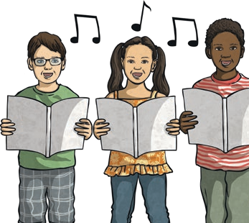

|  |  |  |
| --- | --- | --- |
| ***Performing Together Year 4*** | | |
| **Vocabulary** | style, texture, structure and instruments | |
| **Autumn** | Mamma Mia: Pop |  |
| **Spring 1**  **Spring 2** | Stop! Rap-Grime mix of hip-hop& reggae  Lean On Me-Soul/Gospel |
| **Summer1/2** | Blackbird-Western Pop  Reflect, Rewind and Replay |

|  |  |
| --- | --- |
| ***Key Vocabulary-interrelated dimensions of music*** | |
| **pulse**  **rhythm** | The regular heartbeat of the music: it’s steady beat.  **Long/short sounds or patterns that happen over the pulse.** |
| **tempo** | The speed of the music: fast or slow or in-between.  ***Allegro: at a quick speed***  ***Adagio: at a slow speed*** |
| **pitch** | High and low sounds. |
| **timbre**  **dynamics** | All instruments including voices, have a certain sound quality.  **How loud or quiet the music is.** |
| **texture** | How many layers of sound the music has (thick or thin) |

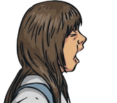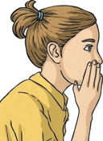

C Composing is the art of creating music and

having a finished product.

**I** Improvising is creating or inventing music ‘on

the spot’ without preparing or practicing it first.

***Composing and Improvising***

crotchet-1 beat

quaver-half a beat

|  |  |
| --- | --- |
| ***Notation*** | |
| ***The link between sound and symbol*** | |
|  |  |
|  |  |

|  |  |
| --- | --- |
| ***Notation*** | |
| ***Musical notation is a system used to visually represent music*** | |
|  | minim-2 beats dotted minim-3beats  semibreve-4 beats |
|  |  |

